**CSE1100 – Programming Concepts with Python**

**Programming Concepts Lab Report**

**Fall 2021**

*By*

Cael Shoop

*Computer Science, B.S.*

*cshoop2018@my.fit.edu*

Friday, September 10, 2021

Homework or Lab #2

Teaching Instructor:

Stefan Joe-Yen, Ph.D.

# 1. Problem Statement

Problem 1

A program is needed to record a user’s full name along with their height in inches. It must then separate their first and last name and convert their height from inches to feet and inches to read the info back to the user.

Problem 2

A program is needed to record 3 integers, which it converts to floats before finding the minimum value, maximum value, and average value before reading them out to the user with 1 decimal place.

# 2. Requirements

Problem 1

1. The software shall prompt the user for input.
   1. The input shall be the user’s full name.
   2. The input shall be the user’s height in inches.
2. The software shall separate the first and last name.
3. The software shall convert the height to feet and inches.
4. The software shall read back the information.

Problem 2

1. The software shall prompt the user for an input of 3 integers.
2. The software shall convert the input to float values while storing them in a list.
3. The software shall utilize the math library to easily determine the minimum and maximum inputs quickly and easily, as well as determine the average.
4. The software shall read back the information.

# 3. Software Construction (Annotated Python Code)

'''Written by Cael Shoop. CSE1100 Lab 2 Problem 1.'''

from math import floor

def main():

# Input

firstName, lastName = input('Hello! What is your full name?\n').split(' ')

height = int(input('What is your height (in inches)?\n'))

# Conversions

heightFeet = floor(height / 12)

heightInches = height % 12

# Output

print('Great to meet you, ' + firstName + '! Here is your profile:\n')

print('\tFIRST NAME: ' + firstName)

print('\tLAST NAME: ' + lastName)

print('\tHEIGHT: ' + str(heightFeet) + '\' ' + str(heightInches) + '\"\n')

if __name__ == '__main__':

try:

main()

except:

print('Error. Main failed to execute correctly.')

else:

print('Please run this script directly.')

'''Written by Cael Shoop. CSE1100 Lab 2 Problem 2.'''

from math import *

def main():

# Input

num0, num1, num2 = input('Please enter three different numbers\n').split(' ')

# Conversions

nums = []

nums.append(float(num0))

nums.append(float(num1))

nums.append(float(num2))

avg = sum(nums) / len(nums)

# Output

print('Thanks. Here are the results:')

print('\tMIN: ' + str(min(nums)))

print('\tMAX: ' + str(max(nums)))

print('\tAVG: ' + str(avg) + '\n')

if __name__ == '__main__':

try:

main()

except:

print('Error. Main failed to execute correctly.')

else:

print('Please run this script directly.')

# 4. Software Testing

Problem 1:

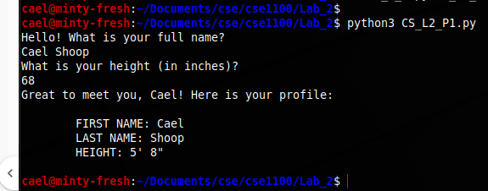

Problem 2:

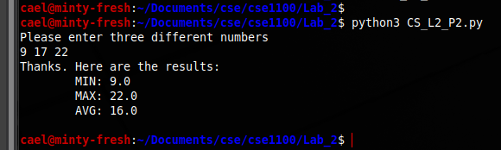

# 5. Self-Reflection

This lab was useful for me. I was reminded of how to work with lists, specifically having to use the append() function. I also got to test out using if-else statements and try-except.